Management Systems Tool

In this tool, there will be an Admin page and UI (user interface) page
- In Admin page, all the inputs related to organization, department, uploading of documents, audit plan creation, audit schedule generation, user management shall be done
- In user interface page – we will have two tabs, (a) document tab and (b) reports tab
- In document tab, document viewing facility shall be available
- In reports tab, audit report creation/publishing, NC report creation/approval workflow/publishing, change request creation/approval workflow /publishing

Details of each feature is being explain below starting with Admin page

Sample Admin page

ADMIN PAGE
ORGANIZATION
CREATE
MODIFY
DEPT/GROUP/PROCESS
CREATE
MODIFY
DELETE
DOCUMENTS LEVEL
CREATE
MODIFY

MASTER DATA
CREATE
MODIFY
SUB-DEPT/GROUP
CREATE
MODIFY
DELETE
DOCUMENTS MNMT
UPLOAD - NEW
UPLOAD - EXISTING

USER MNMT
CREATE
DELETE
PASSWORD RESET
REPORTS MNMT
MODIFY
DELETE
AUDIT MNMT
CREATE AUDIT PLAN
MODIFY AUDIT PLAN
CREATE AUDITORS
MODIFY AUDITORS
GEN. AUDIT SCHEDULE
VIEW & PUBLISH

Fig 1 – Sample Layout of Admin Page

As seen in the above the figure, various sections shall be displayed. I shall be explaining the individual section requirements, conditions, validations (if any)

Organization section: Create

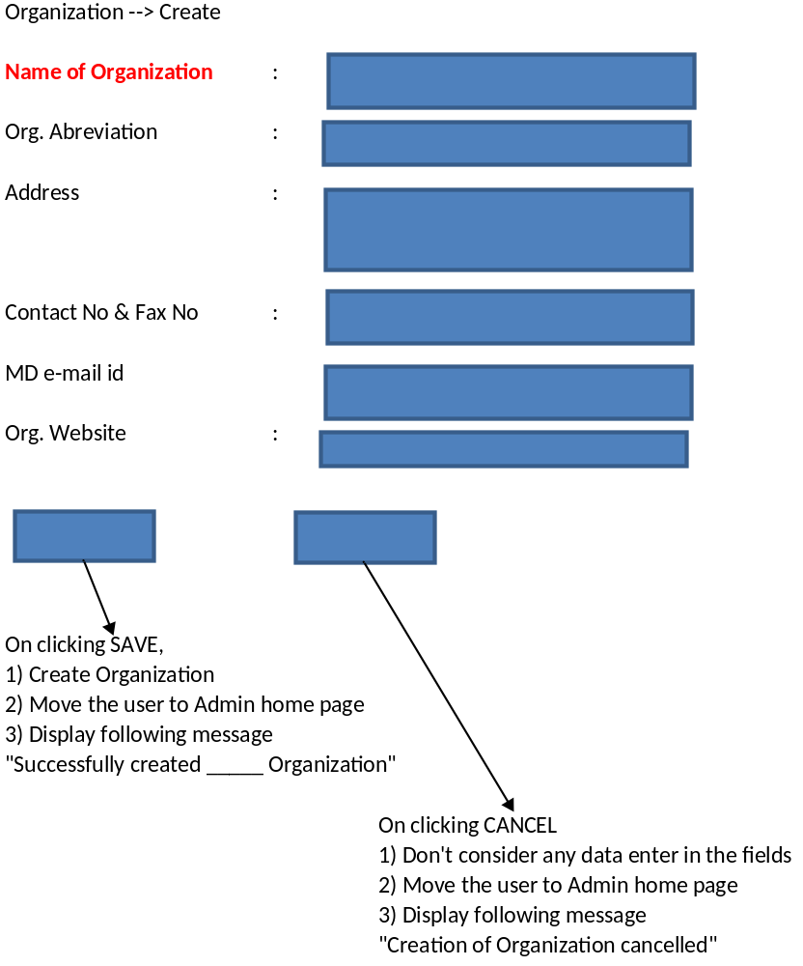

Conditions:

- Until unless, an organization is created, Update option in Organization section shall be in disabled condition (or) show an error, if user clicks on Modify button, without creating an Organization
  - “Organization isn’t created yet”
- Terminology (Dept/Process/Group) shall be selected by user based on their practise in the organization and same shall be considered, wherever applicable (such as - Orange Colour sections in admin page)

Organization Section: Modify
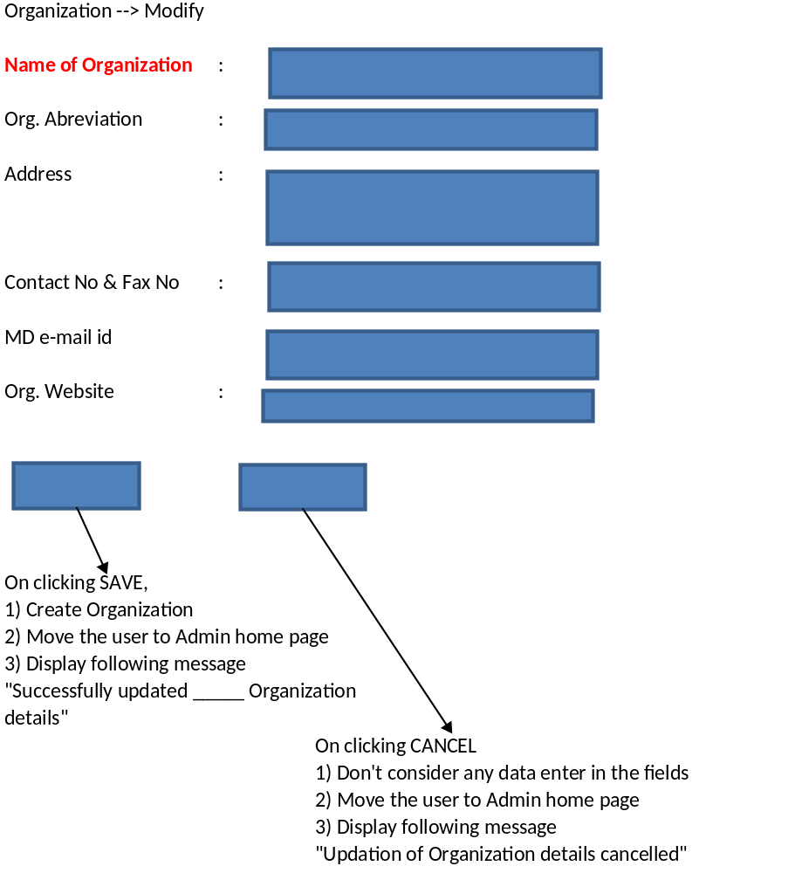

Conditions:
- If name of organization is modified, there shall be an impact on the versioning of the documentation, to be decided
- Other changes (terminology & address) impact also need to be decided

Document Level Section: Create
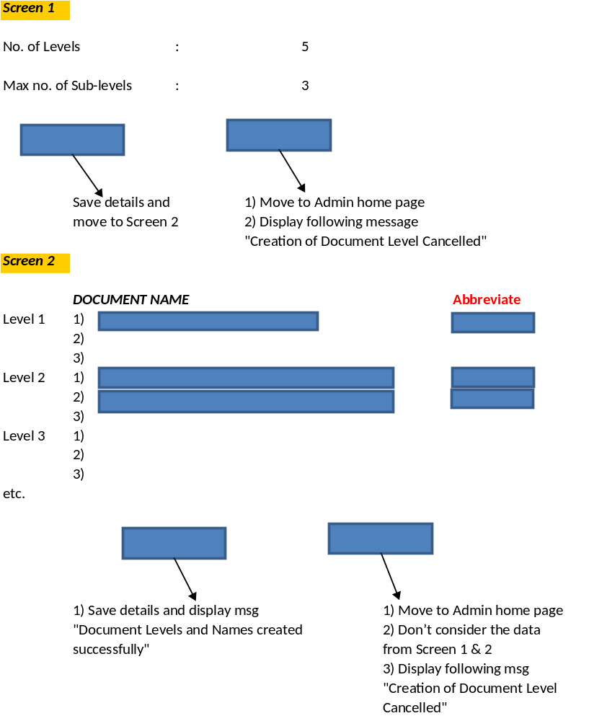
Conditions:
- These details shall be based on Document Control procedure defined by organization
- Abbreviate mentioned shall be considered for documentation numbering

Document Level Section: Modify
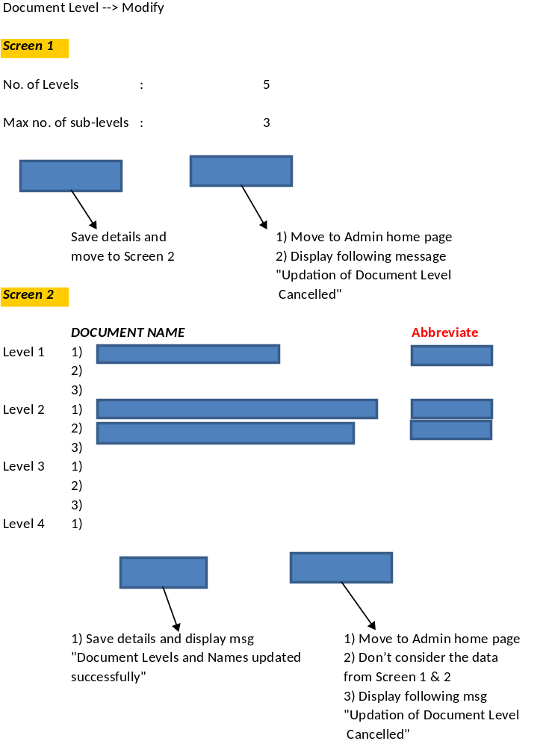
Conditions:
- Updation happen in this tab only based on Doc. Control procedure
- These changes will be done, based on request raised and on subsequent approvals

Dept. Section: Create
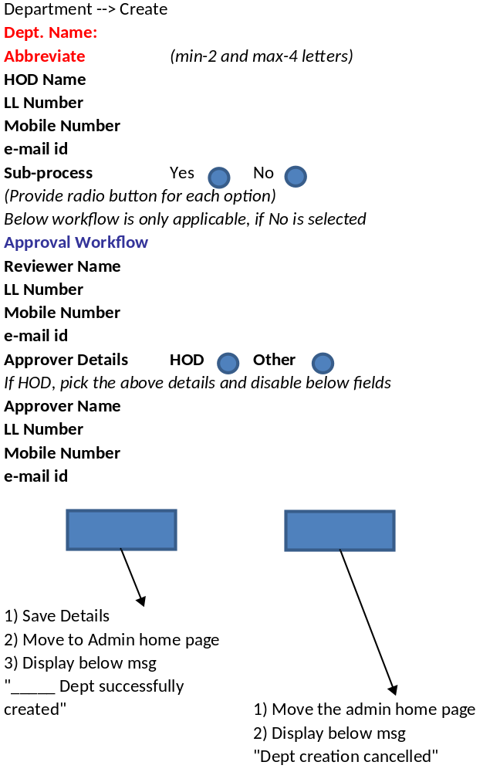

Conditions:
- Here we’re creating departments, which are in the organization
- If there are sub-depts available in a department, radio button provided need to be selected
  - Sub-dept means – In HR, there may two sub-depts like Training & Recruitement
- If sub-dept is mentioned as yes, then, approval workflow shall be captured at sub-process level
- If sub-dept is mentioned as no, then, approval workflow shall be captured at this section only
- The approval workflow shall be considered, while approving documents, NC’s etc

Dept. Section: Modify
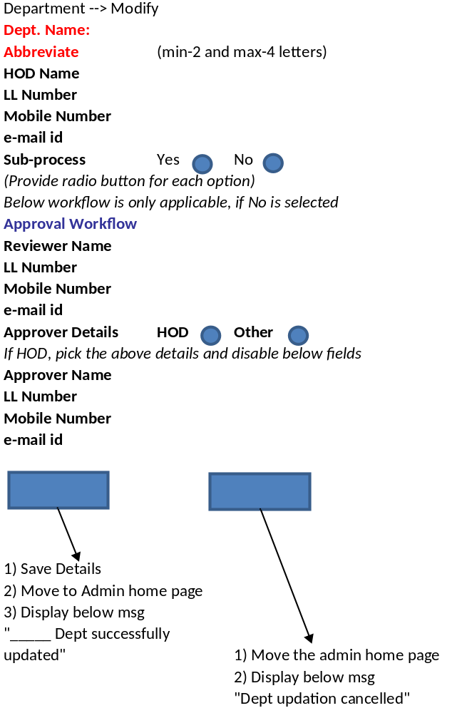
Conditions:
- Impact of modifications done in each field to be determined and finalized
- These changes shall be done based on request raised and on subsequent approvals of request

Department Section: Delete
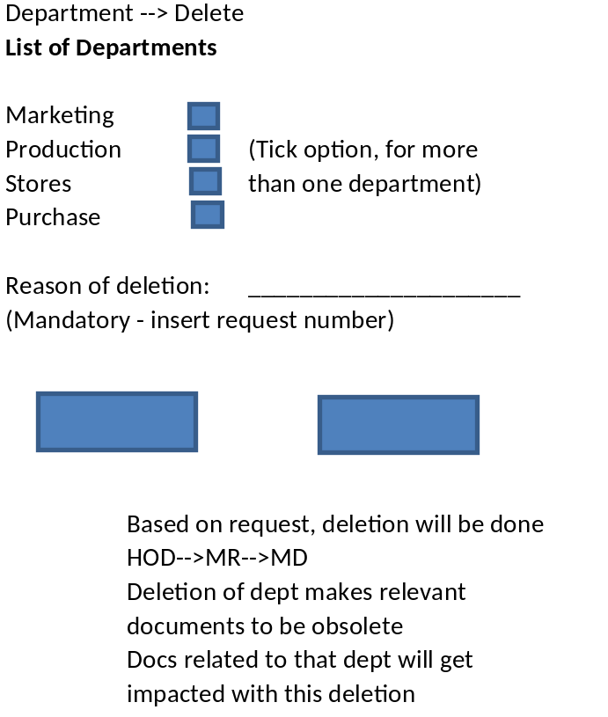
Conditions:
- These changes shall be done based on request raised and on subsequent approvals of request
- Relevant documents to this dept to be made obsolete

Sub-dept Section: Create
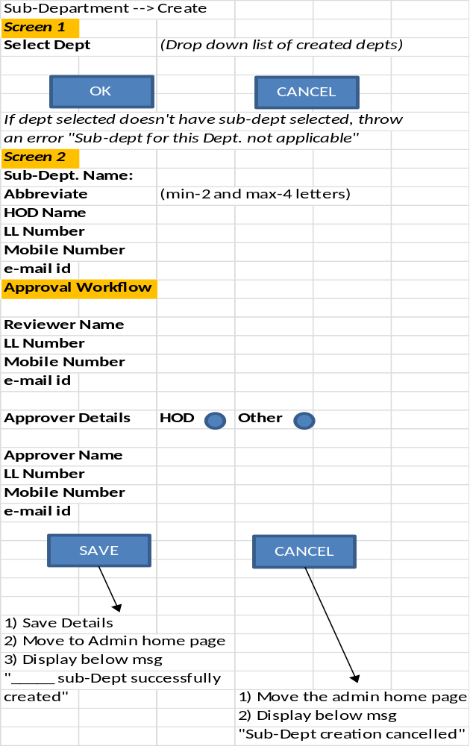
Conditions:
- Here, we’re creating sub-dept to an already created department, subject to selection of sub-dept button during creation of department
- As sub-dept is made applicable, approver details shall be captured at this level

Sub-dept. Section: Modify
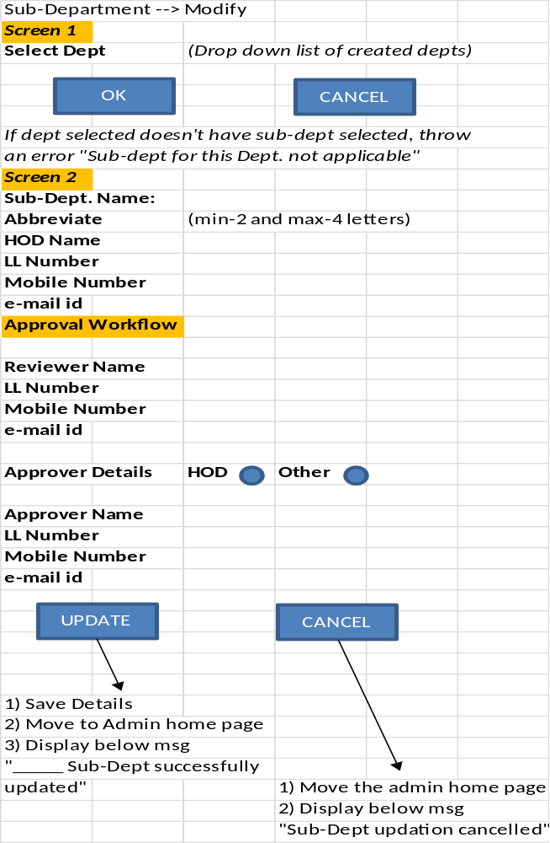
Conditions:
- Impact of changes done to sub-dept to be determined and finalized
- Changes to this section shall be done based on request raised and subsequent approvals only

Sub-dept Section: Delete
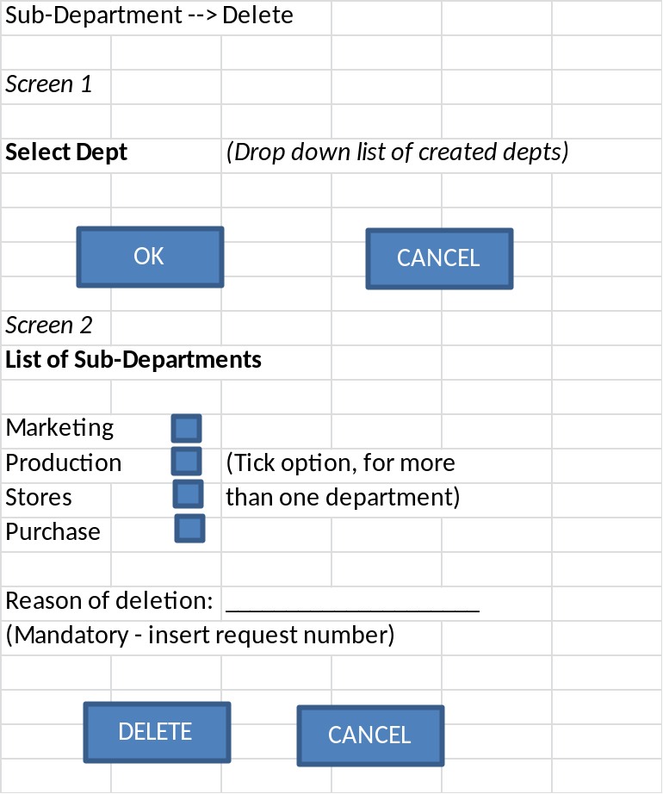
Conditions:
- This section is used to delete a sub-dept/process, if it has been removed from the organization
- Once a sub-dept is deleted, relevant documentation shall be made obsolete

Master Data Section: Create
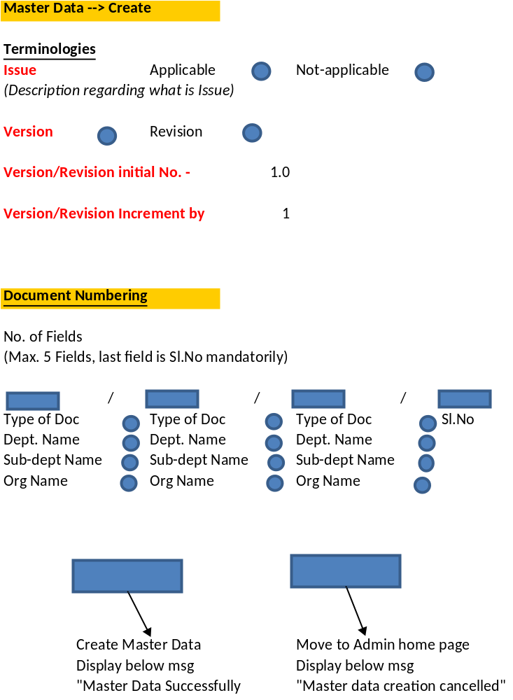
Conditions:
- The inputs for this section shall be document control procedure
- In document numbering, abbreviations captured in earlier sections shall be considered and displayed
- Separator to be selected by organization

Master Data Section: Modify
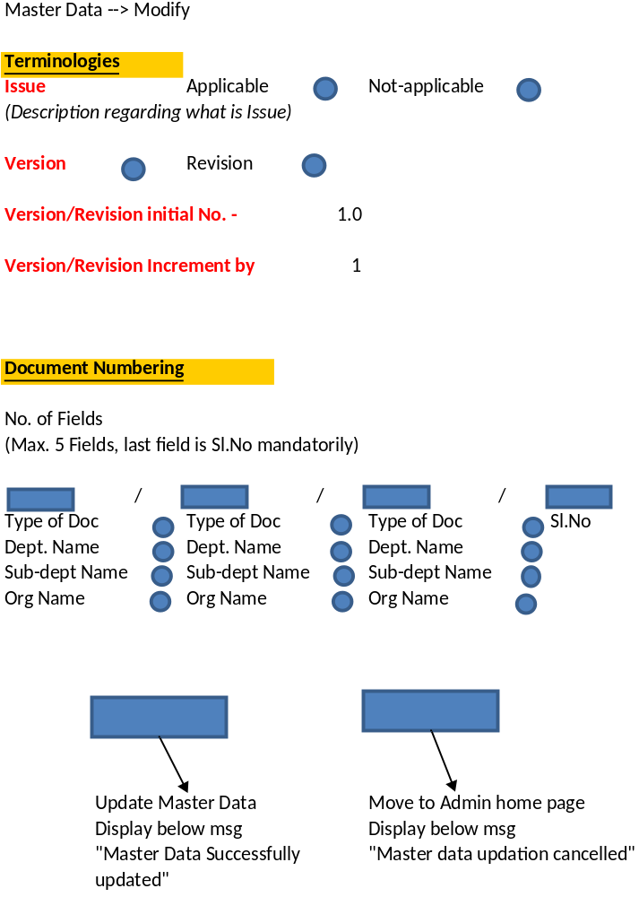
Conditions:
- Impact of changes done to sub-dept to be determined and finalized
- Changes to this section shall be done based on request raised and subsequent approvals only

Doc. Mnmt Section: New
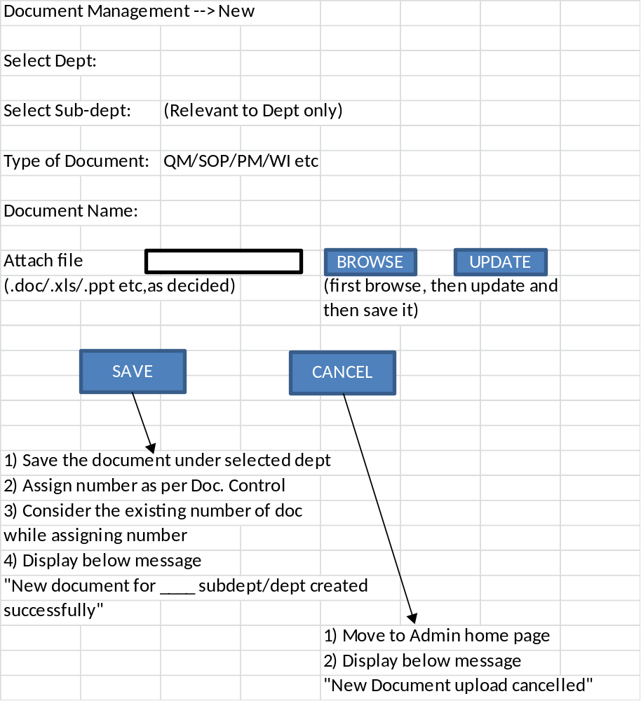
Conditions:
- Methodology for Annexure document creation to be decided
- Page set-up of any type of document is being uploaded to be made as A4 mandatorily
- Documents to be displayed in pdf format

Document Mnmt: Revised Document

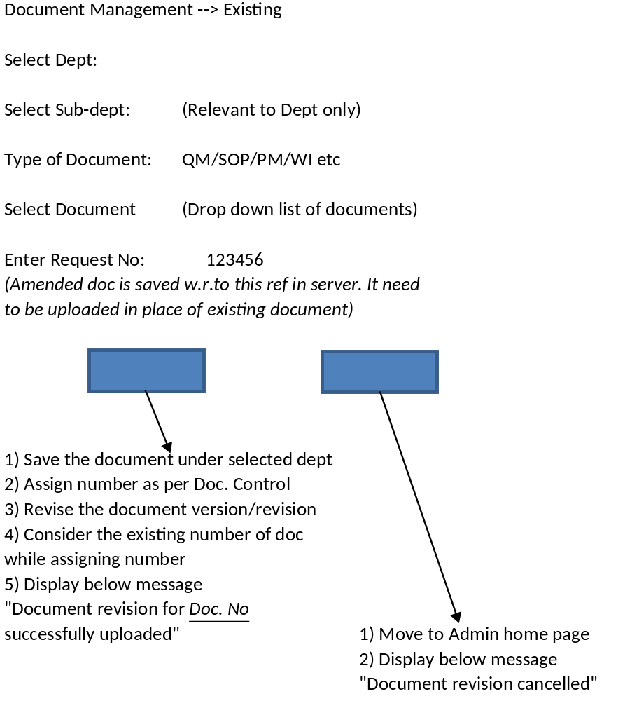

User Mnmt Section: Create
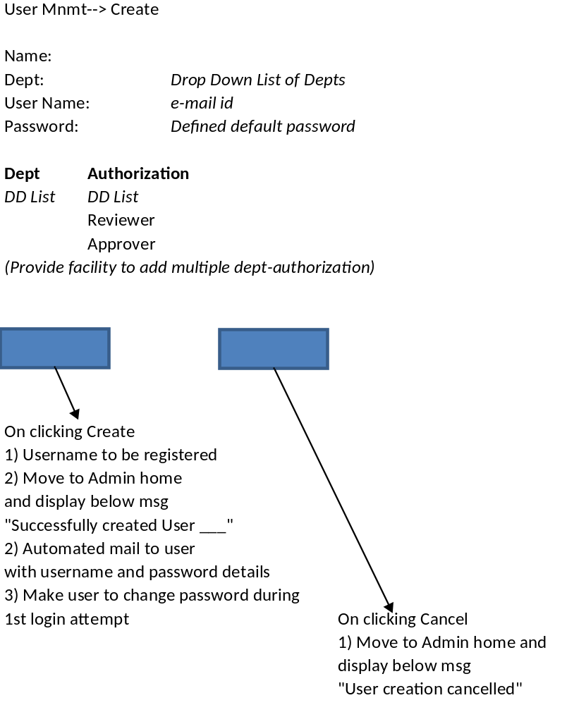

Also, provide User Management → Modify option, as authorization may change for a user in the course of time

User Mnmt Section: Delete

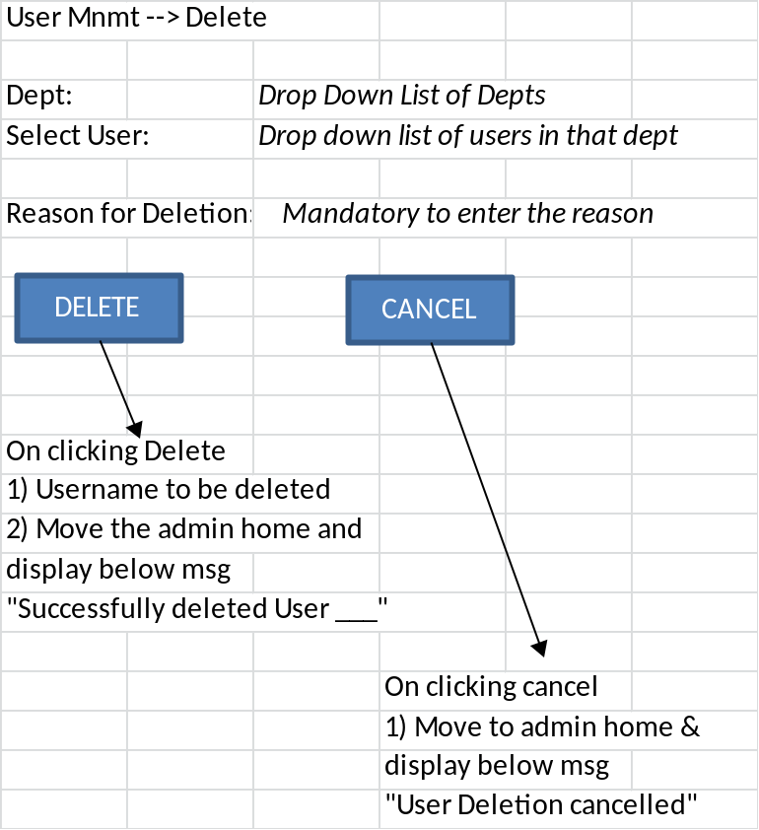

User Mnmt Section: Password Reset
User Mnmt --> Password Reset
Dept: |  |  | Drop Down List of Depts
Select User: |  | Drop down list of users in that dept
New Password:
Confirm Password:
SAVE |  |  | CANCEL
1) Reset the password
2) Move to admin home and display
below msg
"Password reset successful"
3) Trigger mail to user with new
password details
4) Make user to change pw during
1st login attempt with new pw
 |  |  |  | On clicking Cancel
 |  |  |  | 1) Move to Admin home and
 |  |  |  | display below msg
 |  |  |  | "Password reset cancelled"

Audit Mnmt: Create Audit Plan

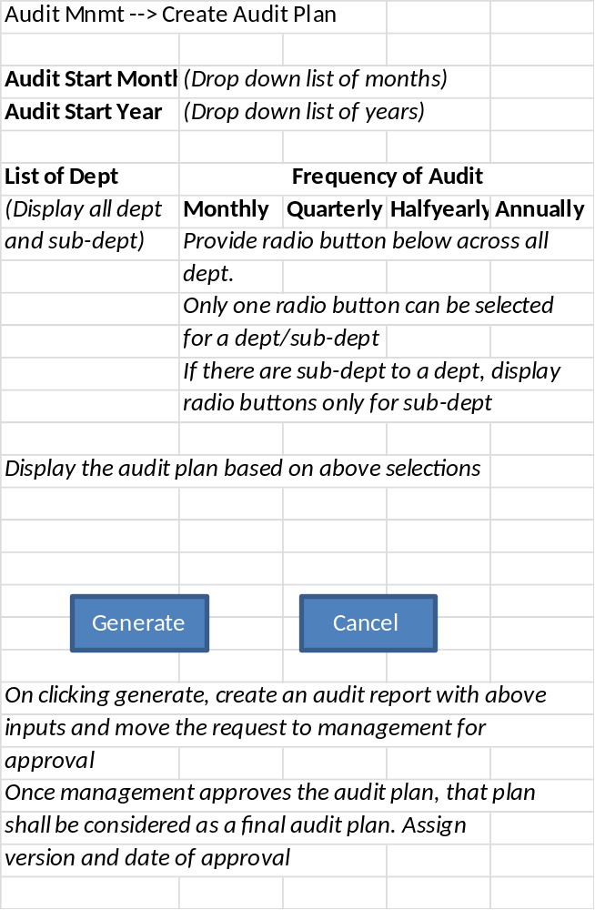

Audit Mnmt: Modify Audit Plan

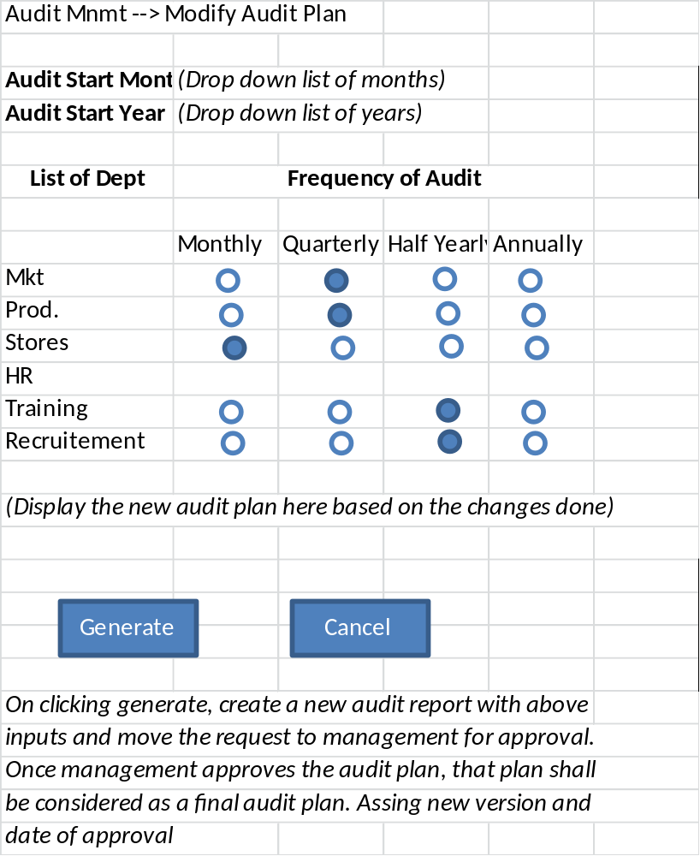

Audit Schedule:
Based on the audit plan, MR should receive an alert mail at the end of every month, notifying the list of departments, for which audit to be scheduled.
After receiving confirmation of dates and availability of auditors, MR shall generate audit schedule
Audit Mnmt --> Generate Audit schedule
Department | Auditee | Auditor | Date | Start Time | End Time
Scheduled Dept list | Default HOD | DD list of Auditors | Calendar | Hr:Min | Hr:Min
 |  |  | (show error, if another month is selected)
 |  |  |  | Cancel
Generate

On clicking Generate, generate schedule |  |  |  |  | On clicking cancel, goto admin page
Show the schedule in Reports Tab (UI), listed under month
Trigger a mail to MR, HOD's and Auditors
An automail, one day prior to schedule to MR, respective HOD & Auditor

A facility to edit/modify the above schedule to be provided to MR.

Audit Mnmt: Create List of Auditors
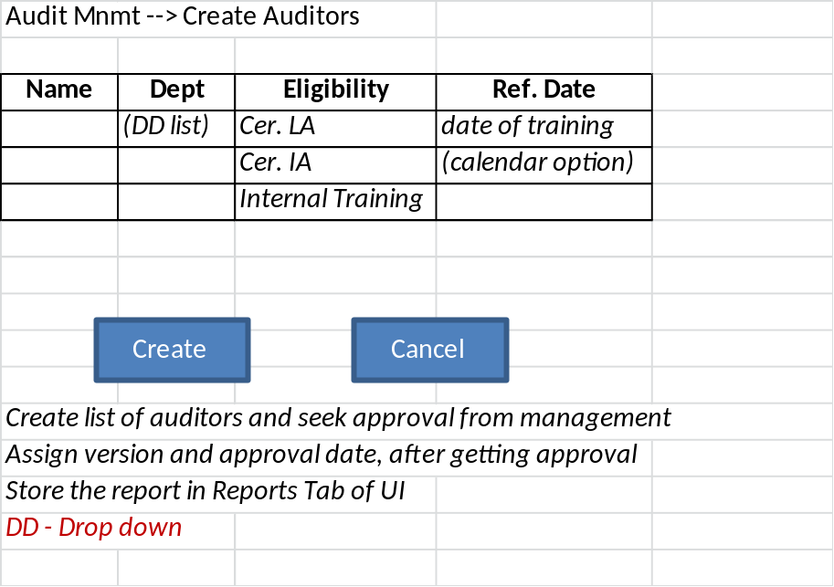

Audit Mnmt: Modify List of Auditors

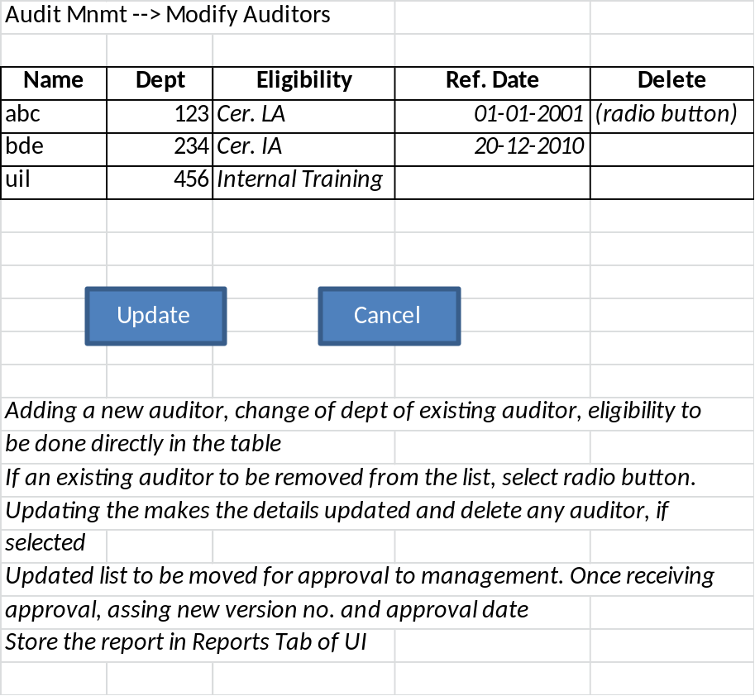

User Interface
Document Tab display
Documents Tab |  | Reports Tab
Document Hierarchy  -Dept wise  or  -Level wise  (as decided)  document names to be displayed as links, upon clicking, they will be displayed in the display area | Document to be displayed in this area

Reports Tab Display
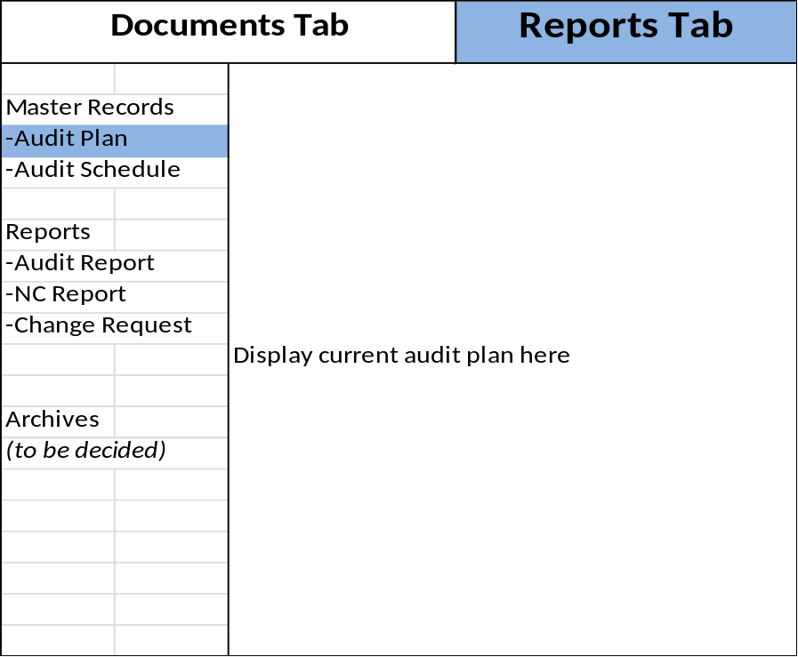

Report Tab – Audit Schedule
Documents Tab |  |  | Reports Tab
 |  | Display upcoming audit schedule here. If no audit schedule is available, display audit schedule to be generated
Master Records
-Audit Plan
-Audit Schedule
Reports
-Audit Report
-NC Report
-Change Request
Archives
(to be decided)
Report Tab – Audit Report
Documents Tab |  |  |  | Reports Tab
 |  | Create button
Master Records
-Audit Plan |  | Dept1
-Audit Schedule |  | → | Jan'12
 |  | → | Feb'12 etc
Reports
-Audit Report |  | Dept 2
-NC Report |  | → | Jan'12
-Change Request |  | → | Apr'12
Archives
(to be decided)

Report Tab – Audit Report
Documents Tab |  |  |  | Reports Tab
 |  | Create button
Master Records
-Audit Plan |  | Dept1
-Audit Schedule |  | → | Jan'12
 |  | → | Feb'12 etc
Reports
-Audit Report |  | Dept 2
-NC Report |  | → | Jan'12
-Change Request |  | → | Apr'12
Archives
(to be decided)
Report Tab – Audit Report
Documents Tab |  |  |  | Reports Tab
 |  | Create button
Master Records
-Audit Plan
-Audit Schedule |  | On clicking Jan'12, open the audit report in a
 |  | new sub tab in non-editable mode
Reports
-Audit Report
-NC Report
-Change Request
Archives
(to be decided)

Report Tab – Create Audit Report
On clicking create button
Documents Tab |  |  |  | Reports Tab
Master Records |  | Month:
-Audit Plan |  | Year:
-Audit Schedule |  | Dept: | (DD List)
 |  | Auditee: | (DD List)
Reports |  | Auditor: | (DD List)
-Audit Report
-NC Report |  | Sl.No | Ref. Doc. | Obser. | Clause, category
-Change Request |  | (as per format, capture the details)
 |  | Once details are updated, move this request to
 |  | auditee for his acceptance
Archives |  | Once accepted, publish the report
(to be decided)
 |  | Only qualified auditor will have the authority to
 |  | create a audit report, others show message as not
 |  | authorized

Report Tab – NC Report
Documents Tab |  |  |  | Reports Tab
 |  | Create button
Master Records
-Audit Plan |  | With Auditee |  | NC No. | Pending With
-Audit Schedule |  |  | → |  | (Name of person)
 |  |  | →
Reports |  | With Auditor
-Audit Report |  |  | →
-NC Report |  |  | →
-Change Request |  |  | →
 |  | Approved & Closed
Archives
(to be decided)
 |  | On clicking NC-01, display the NC report in a new
 |  | sub-tab
Report Tab – Create NC Report
On clicking create button
Documents Tab |  |  |  | Reports Tab
Master Records |  | Provide a blank NC Report
-Audit Plan
-Audit Schedule |  | Based on the Dept selected, move the report to
 |  | the respective HOD for his acceptance(mail)
Reports |  | Once auditee provides RC and CAPA, move the
-Audit Report |  | report to Auditor for his acceptance(mail)
-NC Report |  | Auditor may reject or approve the actions defined
-Change Request |  | If rejected, move back to auditee
 |  | If approved,
Archives
(to be decided) |  | Only qualified auditor will have the authority to
 |  | create a NC report, others show message as not
 |  | authorized
Reports Tab - Change Request

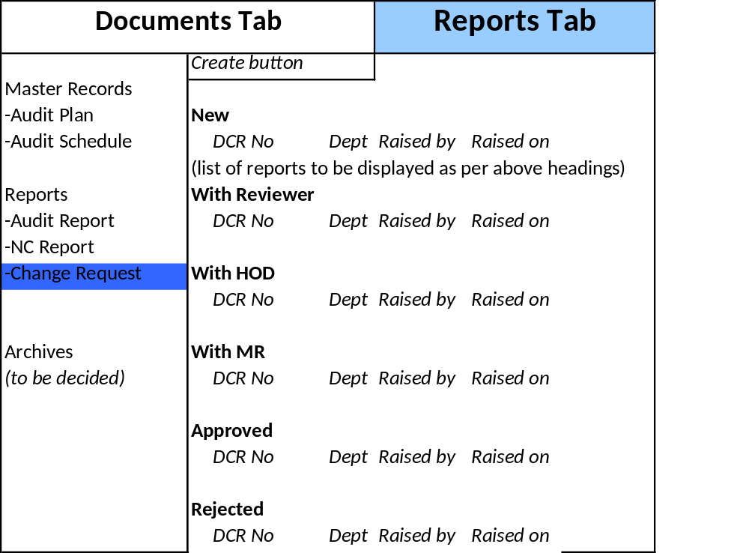

On clicking create button, open a new tab with Change request template

Report Management Modify/Delete
There may be a situation, where a report generated (Audit report, NC report or DC report) will have some errors, which need to be corrected, or to be deleted.
- Provide edit button to MR, who can edit the report, for corrections (at Report Tab – front end only)
- Deletion option should not be provided, rejection button to be provided, which can be used by any person in the workflow, including MR (though he’s in workflow)
- Capture reason for rejection mandatorily

Publish:
Whenever a new change is approved (based on change request), that change may require to be made effective immediately or may be after some time. For this reason, Publish button is used.
- Based on the change request, MR shall be uploading the relevant documents
- New documents uploaded should not replace the existing ones immediately
- All the documents, which were uploaded into the system, should appear as a list in the Publish window
- Based on the need, MR shall be publishing the individual document, by using Publish Button available at Admin page

